Flo patient Information Leaflet V3.2 July 2019

What is Florence (Flo) and how does it work?
Flo will help you before you baby is born and when they arrive by sending useful tips, videos and information such as relationship building, what to expect and support around feeding and safer sleep, by text to your mobile phone

How do I sign up to Flo?
Signing up to Flo is easy! When you have had a chat with your midwife, a few details will be added to the Flo system, including your mobile number. You will receive a message from Flo asking you if you would like to join. If you decide to join, you are giving your consent to share your information across the teams that help to provide your care. Simply reply “YES” to get started. If, for whatever reason, you decide that you want to stop using Flo, you simply need to send “STOP” at any time, and Flo will stop sending you messages. The choice is yours!
Flo will send you friendly reassuring texts throughout your pregnancy from 28 weeks until your baby arrives. Simply then text in ‘BIRTHDAY’ within 5 days of their arrival, followed by their Date of Birth, so that Flo can continue to send you useful information texts to help you as a new mum. If you need further help with feeding your baby, you can text ‘HELP’ to Flo. You will receive a text with details of how you can contact a Specialist Infant Feeding Midwife.

Does Flo cost me anything?
No! If you are receiving messages from Flo, or replying to her from the UK you will not be charged for the messages – you can even use Flo if you have a phone with no credit! You may use data if you click on links within the messages.
Your very first text might look like any of these 3. You will NOT be charged for any reply, and you do not need to click on the link in the message.
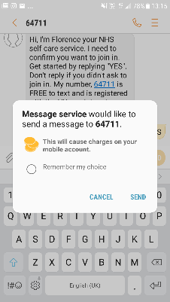
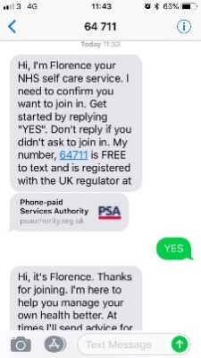

My information
Your personal data is collected and held specifically for the purposes of providing you with the Florence text based messaging system. Consent is required for The Dudley Group NHS Foundation Trust to process your sensitive personal data, but it must be explicitly given and we will tell you why and how the information will be used– this was on the consent form you completed. Understand that you can request to have all of your personal data deleted at any time, otherwise your information will be held for 5 years following the last text message you receive. All data given will be stored and transported securely. https://www.getflorence.co.uk/legals/data-retention-policy/

